**Extended Essay**

*Computer Science*

RQ: **To what extent is the run time efficiency and accuracy between the momentum algorithm and the mean reversion algorithm differ in evaluating the profits for stock trading?**

Word Count - 3935

**Mean reversion and Momentum Algorithm**

**May 2023**

**INTRODUCTION** **3**

**SECONDARY RESEARCH** **4**

Momentum Algorithm 4

What is the Momentum Algorithm? 4

Factors affecting the Momentum Algorithm 5

Indicators of the Momentum Algorithm 5

Example of the Momentum Algorithm 6

Limitations of the Momentum Algorithm 7

Mean Reversion 8

What is the Mean Reversion Algorithm? 8

Indicators of Mean Reversion Algorithm 8

Example of the Mean Reversion Algorithm 9

Limitations of the Mean Reversion Algorithm 10

Benefits of Momentum Algorithm and Mean Reversion Algorithm 11

Previous Results of the Algorithms after Backtesting 11

Momentum Algorithm 11

Analysing backtesting results 13

**Secondary Research Analysis** **14**

**PRIMARY RESEARCH** **16**

Data Source 16

Mean reversion 16

Code 16

Explanation 20

Results 23

Momentum Algorithm 25

Code 25

Explanation 27

Results 29

**Primary Research Analysis** **29**

**Conclusion** **30**

# 

# 

# INTRODUCTION

Technology, with its characteristic dynamic, evolutionary, and revolutionary capabilities, has found its path into the stock market. Consequently, this has led to the creation of a particular method of trading known as algorithmic trading, where hundreds of different pre-programmed computer algorithms are being deployed to generate revenues at a rate and efficiency that a human could never achieve. accounting for variables such as time, price, and volume. I was exposed to this area of study during my winter internship where I created programs and charts . Two very popular algorithms used are the momentum algorithm and the mean reversion algorithm. Therefore, my extended essay is based on the question: **To what extent is the run time efficiency and accuracy between the momentum algorithm and the mean reversion algorithm differ in evaluating profits for stock trading?**

Delving further into the details of the algorithm, I aim to understand the working of these programs based on logic and computation delving further into the details of the algorithm. I compare these algorithms using previous results of the algorithms **from** the back testing conducted by other users in 2021. Later on, based on this analysis, I conduct primary research using a virtual simulator of the stock market to compare and contrast the real-time efficiency by calculating the time taken by the momentum algorithm and the mean reversion algorithm in generating profits. Depending on the fluctuation of the price and results of implementing these algorithms, I will reach a conclusion regarding to what extent both algorithms are similar or different in terms of accuracy.

# SECONDARY RESEARCH

## Momentum Algorithm

### What is the Momentum Algorithm?

The term Momentum trading is derived from the same term used in physics that is used to describe a body's quantity and path of motion. The momentum algorithm is a trading strategy in which a purchase of rising stocks occurs and are later sold when they appear to have reached their zenith(Barone, Adam).

Momentum Algorithmic Trading is analysing stocks in the short term and buying those whose prices are rising rapidly. The computer then sells the equities when the price appears to have peaked, profiting. The core premise is that if a price change has enough momentum behind it, it will continue in that direction. The idea is to work with volatility by looking for purchasing opportunities in short-term uptrends and selling when the stocks lose their momentum. The investor then withdraws the funds and searches for the next short-term rally, or purchasing opportunity, prior to repeating the process. Skilled traders know when to enter a position, hold it for how long, and exit it; they can also respond to short-term news-driven spikes or selloffs.

### Factors affecting the Momentum Algorithm

A number of factors influence an asset's short-term price shift. The following are a few of these factors:

1. Fundamental factors: If a firm releases positive or negative fundamental news, its stock price will travel in a specific direction for the next few weeks or days.
2. News events: Certain news events have an impact on a stock's momentum.
3. Market volatility: When trading with momentum, market volatility is an important element to consider because a position is taken after the stock price has begun to move, high volatility indicates that the stock has the ability for its price to rise further, allowing you to profit.
4. Herd Effect: In bearish markets, people who join groups and follow the activities of others are said to have a herd instinct, on the presumption that others have completed their research. The herding effect diminishes momentum traders' profit margins.

### 

### Indicators of the Momentum Algorithm

The momentum algorithm includes many indicators like:

1. Momentum Indicator: An oscillating indicator used to confirm the direction of the stock’s **cost** activity.
2. RSI Indicator: Measures oscillations in buying and selling pressure. “​​Oscillators are momentum indicators used in technical analysis, whose fluctuations are bounded by some upper and lower bands”(Chen,James).
3. Moving Averages: Identifies emerging trends in the stock price.
4. Breakout Indicator: Identifies the breakout in price or volume.

## 

### Example of the Momentum Algorithm

In this case the algorithm utilises two moving average lines, namely the fast moving average and slow moving average.

The two moving averages are the slow-line, or the slow-moving average has a larger time duration, here it is 200. The **fast moving average** on the other hand, or the fast-moving average has a smaller time duration, **here it is** 50.

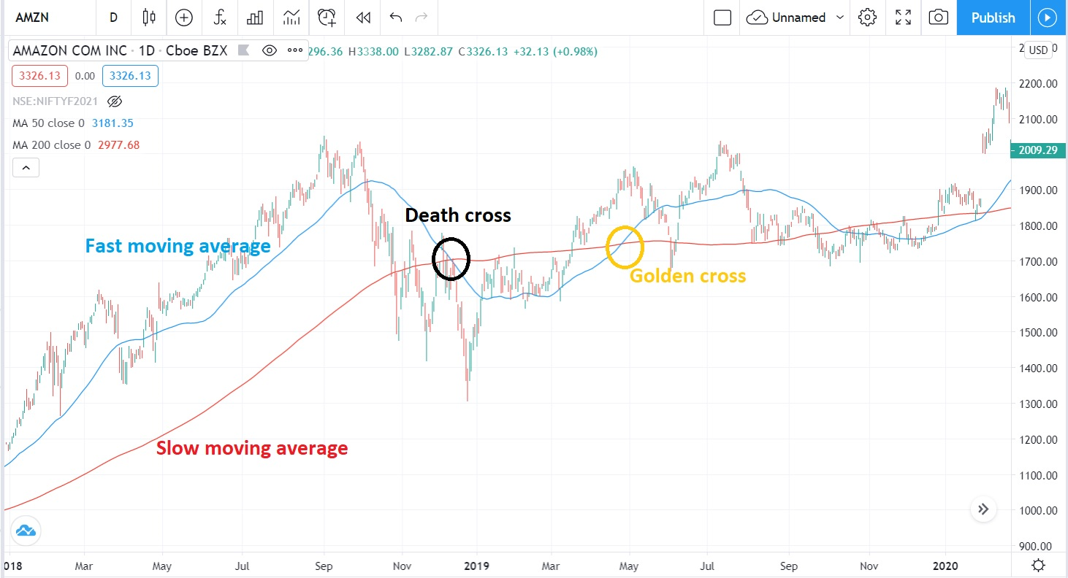

*Fig 1: Example of Momentum Algorithm*

The golden cross is a chart pattern that represents a price trend that is bullish. When the fast moving average travelling in an upward path (i.e. from below to above) intersects the slow moving average travelling in an downward path, it forms a golden cross.

A bearish trend is indicated by a death cross. When the fast line intersects the slow moving average in a downhill direction(i.e. from above to below), this occurs.

### Limitations of the Momentum Algorithm

1. Timing of entry and exit: This algorithm is very time sensitive. If the entry position is acquired too late, the investment may end up being a loss making decision. Similarly, even after spotting the opportunity, if the slowdown of momentum is mistakenly spotted and a position is abandoned too soon, you miss out on prospective gains.
2. High Transaction Cost: In comparison to long-term value investing or buy-and-hold strategies, the number of overall trades can be significant because this sort of approach identifies short-term opportunities. As a result, transaction costs rise.
3. Time-consuming: The trader must keep a careful eye on the opportunities and keep up with all important news for the stock being traded.
4. Trend-reversal: The momentum strategy is based on the assumption that the current trend will continue in the same direction. However, occasional reversion of this trend can lead to the downfall of this particular strategy.

## 

## Mean Reversion

### What is the Mean Reversion Algorithm?

“Mean reversion, or reversion to the mean, is a theory used in finance that suggests that asset price volatility and historical returns eventually will revert to the long-run mean or average level of the entire dataset”(Chen, James). ​​Many financial strategies, ranging from stock trading tactics to options pricing models, are based on the mean reversion principle. Mean reversion trading seeks to profit from large swings in a security's price by believing that it will return to its former condition. It is not limited to percentage returns and prices; interest rates and even a company's P/E ratio can be affected by this phenomena.

### Indicators of Mean Reversion Algorithm

The mean reversion algorithm has a few prominent indicators like:

1. Bollinger Band: A Bollinger Band is a technical analysis tool characterised by a series of trendlines plotting two standard deviations (positively and negatively) away from a security's price's simple moving average (SMA), but which can be altered to the user's preferences.
2. Economic Indicator: Numerous traders will examine economic data for mean reversion. For example rate unemployment, Gross Domestic Production.
3. Sentiment Indicators: **Numerous investors consider these indicators** because the market is a reflection of the public. These types of mean reversion indicators frequently discover good turning points.

If 70% of investors are bearish, for example, this could indicate that the market is overly pessimistic.

1. RSI Indicator: The same as in momentum trading. Many traders use RSI to complement their mean reversion strategy. RSI is useful because it helps them determine which asset exhibits overbought or oversold price levels.

### Example of the Mean Reversion Algorithm

An **instance of** the Mean Reversion Algorithm is when buying a stock after it has undergone a significant drop. When a stock's price declines, there's a strong probability it'll bounce back to its previous levels.

When investing in stocks, the method is to keep an eye out for extraordinary events and gamble on things returning to normal.

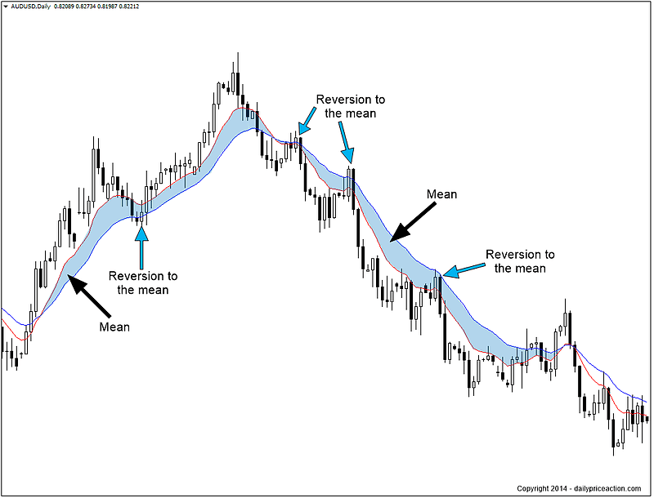

*Fig 2: Example of Mean Reversion Algorithm*

### Limitations of the Mean Reversion Algorithm

By analysis of the mean reversion algorithm, we notice that there are not a lot of limitations of the mean reversion algorithm.

Firstly, a disruption in the regular pattern can be indicated by untimely highs and lows, therefore a return to the previous trend is unlikely. On the positive side, new service launches or advancements; on the negative side, bans and suits are examples of such events.

Even the most catastrophe could cause a mean reversion in an asset. However, as with most market action, there are no guarantees regarding how specific occurrences have an effect on general appeal of specific assets.

### Benefits of Momentum Algorithm and Mean Reversion Algorithm

1. The best potential pricing is used to conduct trades.
2. The placement of trade orders is quick and precise.
3. To avoid substantial price swings, trades are timed precisely and promptly.
4. Transaction costs are less.
5. Timely and periodic confirmation of multiple stock conditions at the same time.
6. When placing transactions, there's a lower chance of making a mistake.
7. Reduced the danger of investors making errors because of emotional and psychological variables(Singh, Gaurav).

### Previous Results of the Algorithms after Backtesting

I have chosen two specific instances of both these algorithms of the same stock which is infosys and within the same time frame of 2021.

### Momentum Algorithm

The algorithm used here is the Bullish Momentum that initiates a buy position when the momentum picks up as indicated by the momentum indicator. An exit is taken if the price falls below support level. Suitable for bullish trending markets.

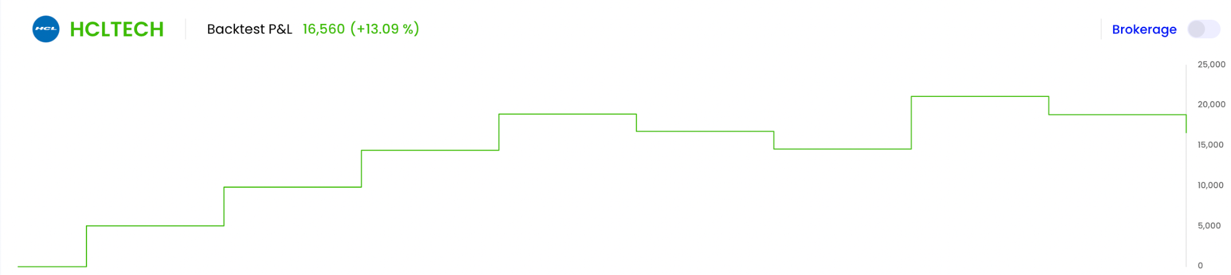

*Fig 3: Backtesting results of Momentum Algorithm*

**Results:**

Total number of signals: 9

Number of wins: 5

Number of losses: 4

Winning streak: 4

Losing streak: 2

Max gains: 6530.00

Max loss: -2295.00

Avg gain/winning trade: 5093.00

Avg loss/losing trade: -2226.25

Max DD: -0.2300

**Mean Reversion Algorithm**

The algorithm chosen here is Bollinger Mean Reversion. The bullish strategy uses Supertrend, Bollinger band and RSI to signal an entry when the stock price deviates substantially from the average price for the stock to revert back to the mean price.

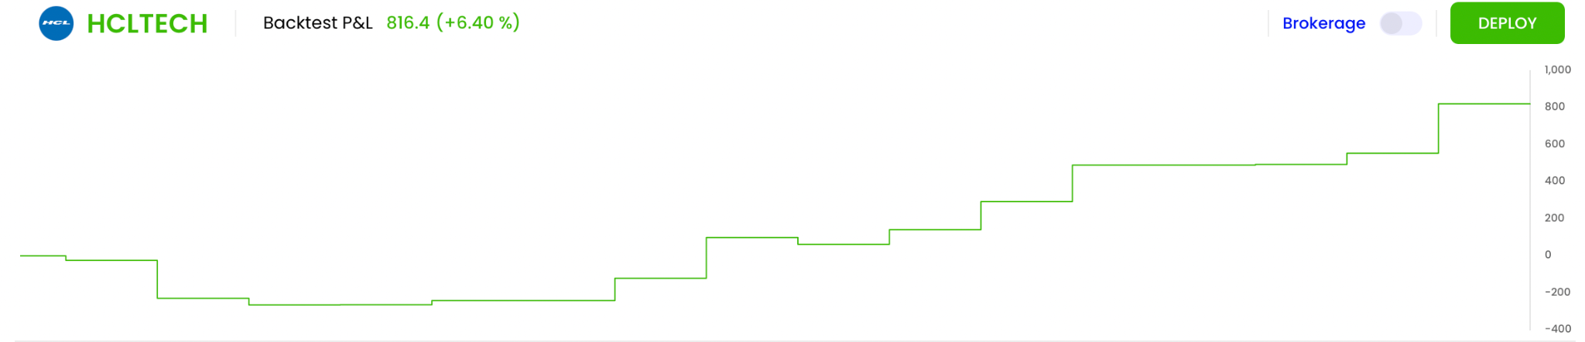

*Fig 4: Backtesting Results of Mean Reversion Algorithm*

**Results:**

Total number of signals: 17

Number of wins: 12

Number of Losses: 5

Winning streak: 6

Losing streak: 3

Max gains: 266.20

Max loss: -203.80

Avg gain/winning trade: 112.22

Avg loss/losing trade: -61.16

Max DD: -3.7117

## Analysing backtesting results

Through the backtesting of the momentum algorithm and mean reversion algorithm, we can compare their results and give us a better indication. Firstly while comparing the total signals, which is basically the sum of the number of losses and number of profits by the algorithms, we notice that the total number of signals of the mean reversion algorithm, 17, is higher than that of the momentum algorithm, 9. Therefore we can deduce that the mean reversion algorithm is more efficient than the momentum algorithm, thus highlighting the risky nature of the momentum algorithm and underscoring the more safer approach of the mean reversion algorithm. The number of wins, 12, of the mean reversion is significantly higher than the number of losses, 5, compared to the number of wins, 5, of the momentum algorithm and the number of losses, 4, which are very close to each other which emphasises that the momentum algorithm is riskier. The max gain of the momentum algorithm, 6530.00 , and the max loss, -2295.00, is exponentially higher than that of the mean reversion algorithm - max gain: 266.20 and max loss: -203.80. Therefore the max loss and gains of momentum algorithm balances out for its lack of efficiency compared to the momentum algorithm. A similar conclusion can be deduced from the average winning trade, 112.22 and average losing trade, -61.16 of the mean reversion algorithm when contrasted with the average winning trade, 5093 of the momentum algorithm and average losing trade, -2226.25. All these factors accumulate to give us the total profit and loss for both algorithms. In this case, it is about 816.40(about 6.4%) for the mean reversion algorithm and 16560(about 13.09%) for the momentum algorithm.

## Secondary Research Analysis

After conducting thorough secondary research, we can now compare both algorithms, the momentum algorithm and the mean reversion algorithm respectively.

Firstly we can compare the working of both the algorithms. Based on the definition and explanation the momentum algorithm mainly works by primarily identifying the stocks whose price is increasing at a steady rate or even rapidly sometimes. Next after conducting multiple checks of the stock by referencing indicators like the momentum indicator, RSI indicator, moving averages and breakout indicator at the same time it buys. Later it holds on until the algorithm assumes that the stock has reached its zenith and is likely to fall next. Thus by buying a stock at a supposedly lower price and then selling it at its assumed extreme high price. In this case the primary assumption is that if the stock price is rising rapidly, it should continue to rise until a certain point and then sell at this point. It is efficiently able to generate profits. Meanwhile, according to the definition and explanation of the mean reversion algorithm begins with calculating the average state in the long of a stock, in this case HCL technologies through the analysis of evaluation of historical data gathered previously or imported. Thyen the mean reversion algorithm uses indicators such as bollinger bands, economic indicators, sentiment indicators and RSI indicators to check on stocks Next when a stock reaches a point below the average state it can then buy the dip in the price of the stock. It holds onto this stock until it reaches back to the average state. It then sells or vends of this stock at or around the average state to generate profits. So according to this, the primary assumption of this algorithm is that the price will return back to its average state in the long run. Therefore through this, we can see a clear demarcation in the assumptions of these strategies.

Judging by this we can notice that the momentum algorithm is comparatively more risky as the assumptions need to be very accurate and are not really based on a mathematical formula or function to give it more objectivity. Being risky the momentum algorithm is considered to have both a higher profit margin but also a very high loss margin in the case the current scenario or situation is not very favourable leading to the momentum algorithm to fail. Next the mean reversion is comparatively very safe as it involves mathematical formulas and functions which adds an element of objectivity. Being comparatively safer, the loss margin is very low but the profit margins are shorter as well. Not a lot of loss is incurred by the mean reversion algorithm whenever the situation is not favourable, however profit generation is slow and requires more time than the momentum algorithm. Therefore the momentum algorithm is much more time sensitive when compared to the mean reversion algorithm.

This process has been very useful as it will aid in primary research and gives an indication of what to expect next. It has also given a broader understanding of the algorithms in terms of their working and benefits, limitations.

# 

# PRIMARY RESEARCH

## Data Source

For primary data collection, I have used the source yahoo finance as it contains all historical data such as closing price, opening price, low price and high price for every day of the week the stock market in India was functional for all stocks. It can also easily be installed through the terminal and then later imported into the python code. This source is one the most credible sources for stock market algorithm analysis. Yahoo Finance is also very efficient in gathering real time data and live status updates of stocks. Therefore considering all these factors, I choose yahoo finance as the main data source for stock prices.

## 

## 

## Mean reversion

### Code

According to Raposa.trade, the python code for mean reversion is as follows:

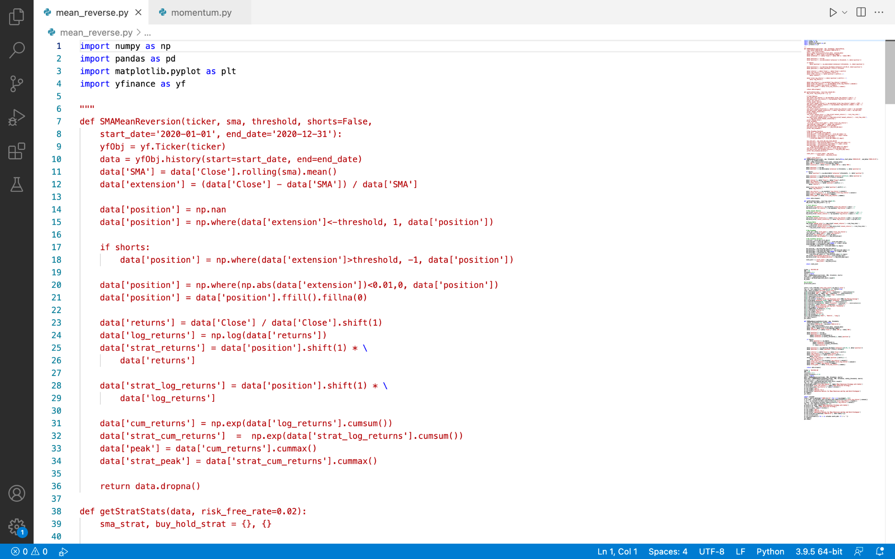

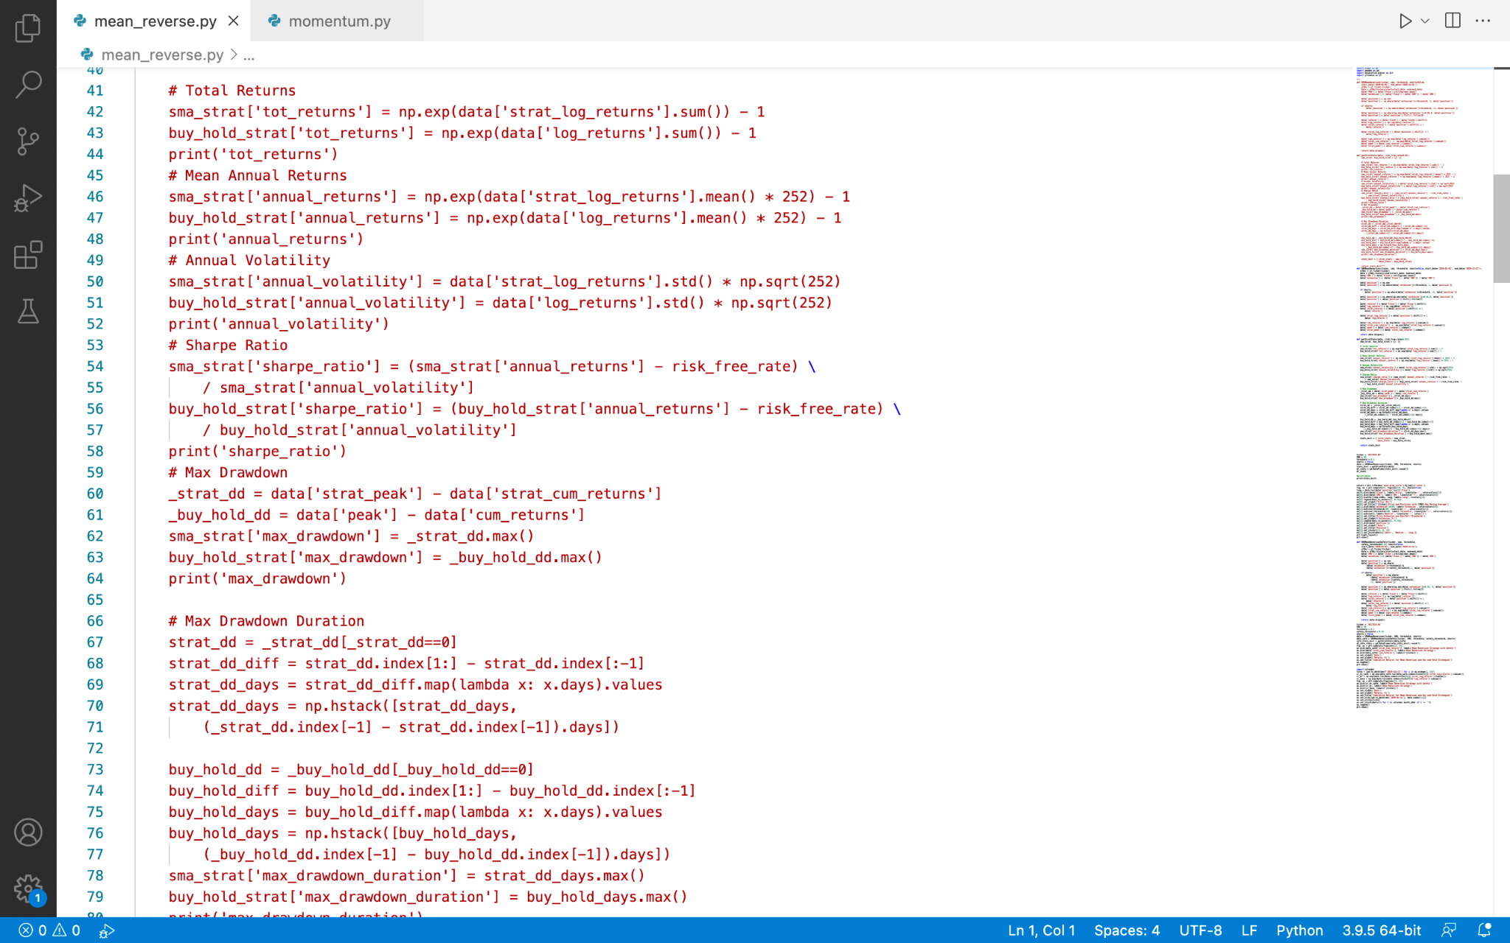

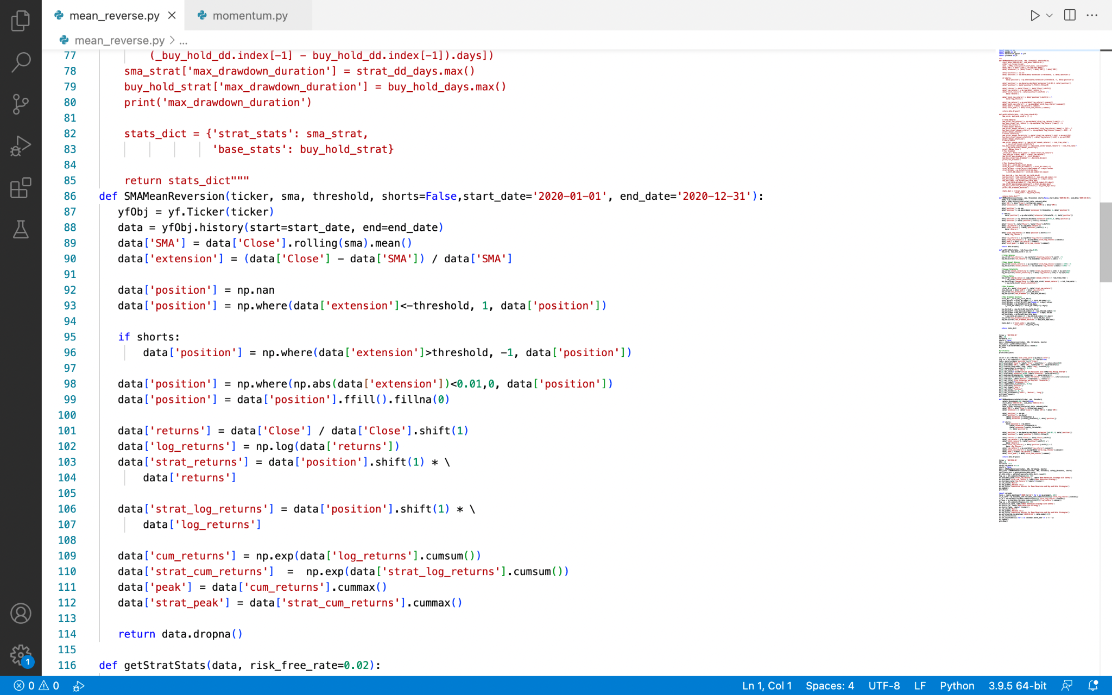

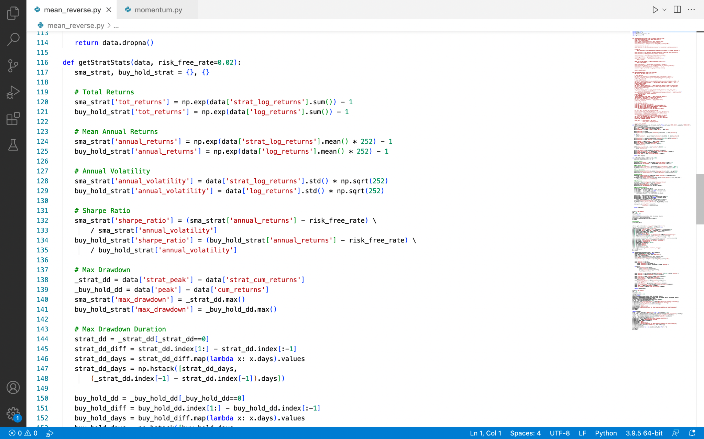

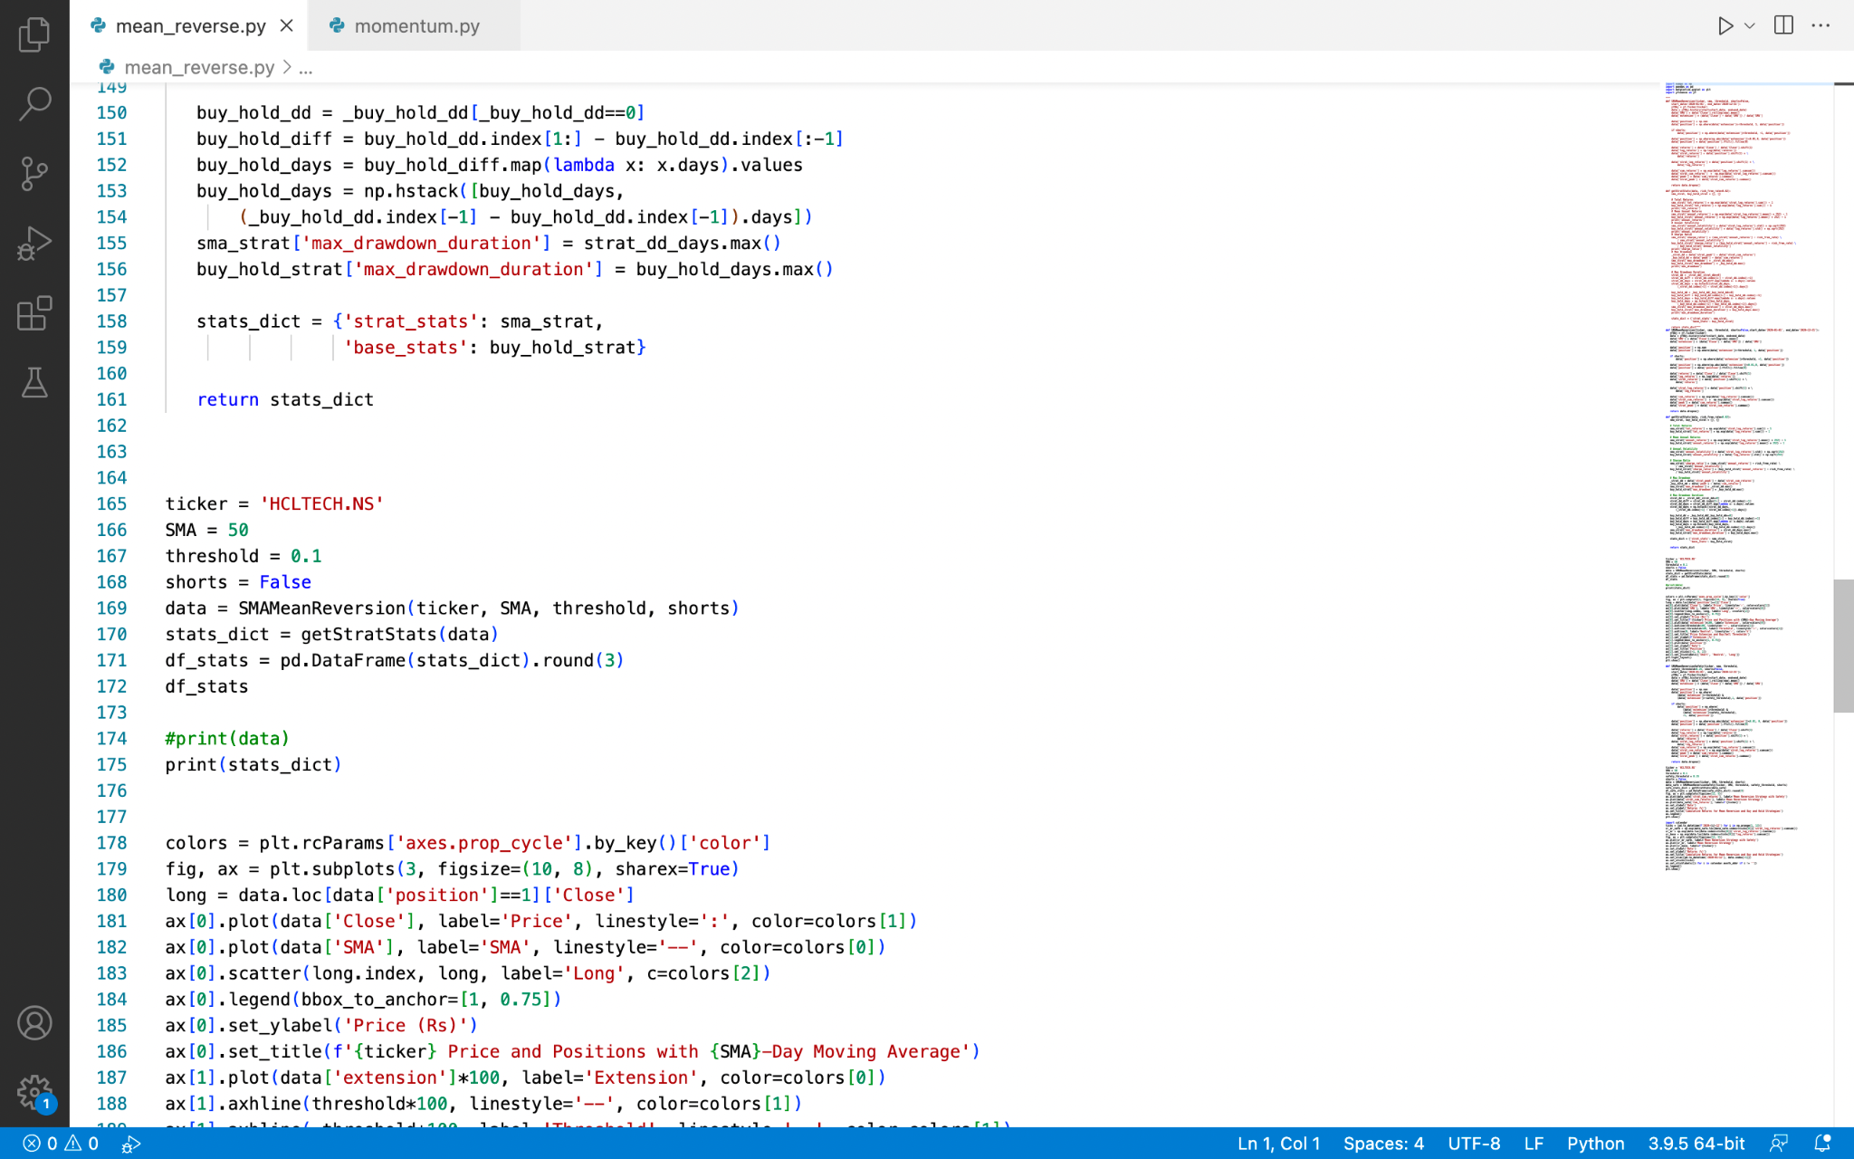

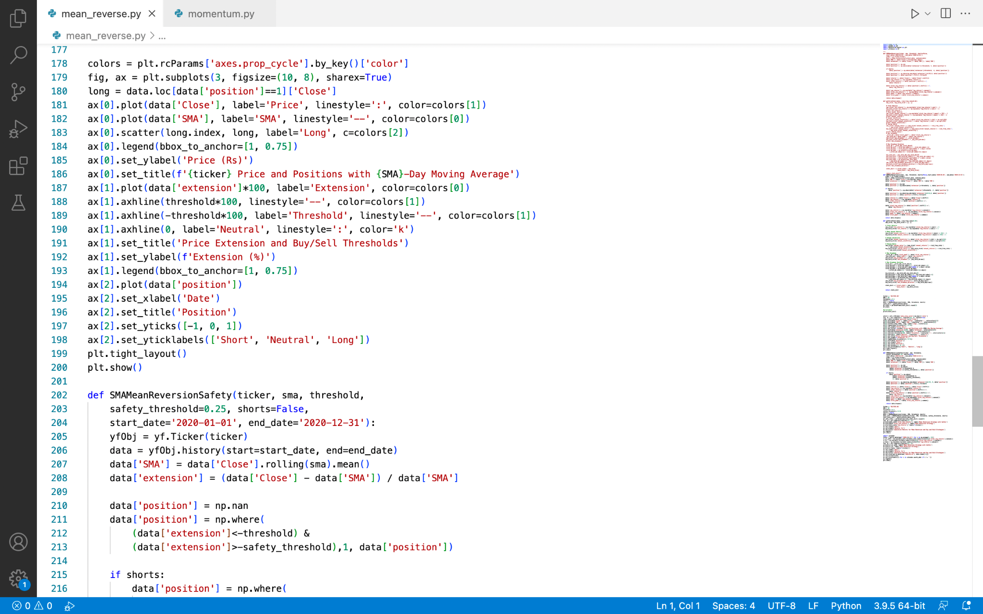

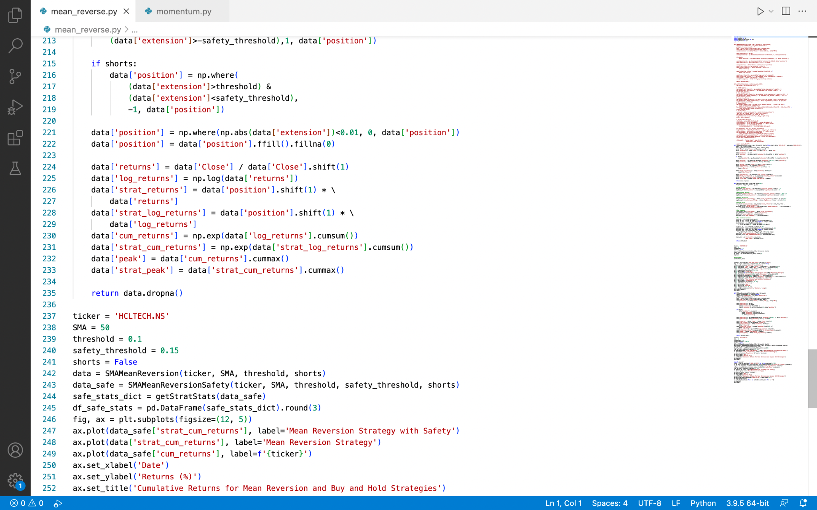

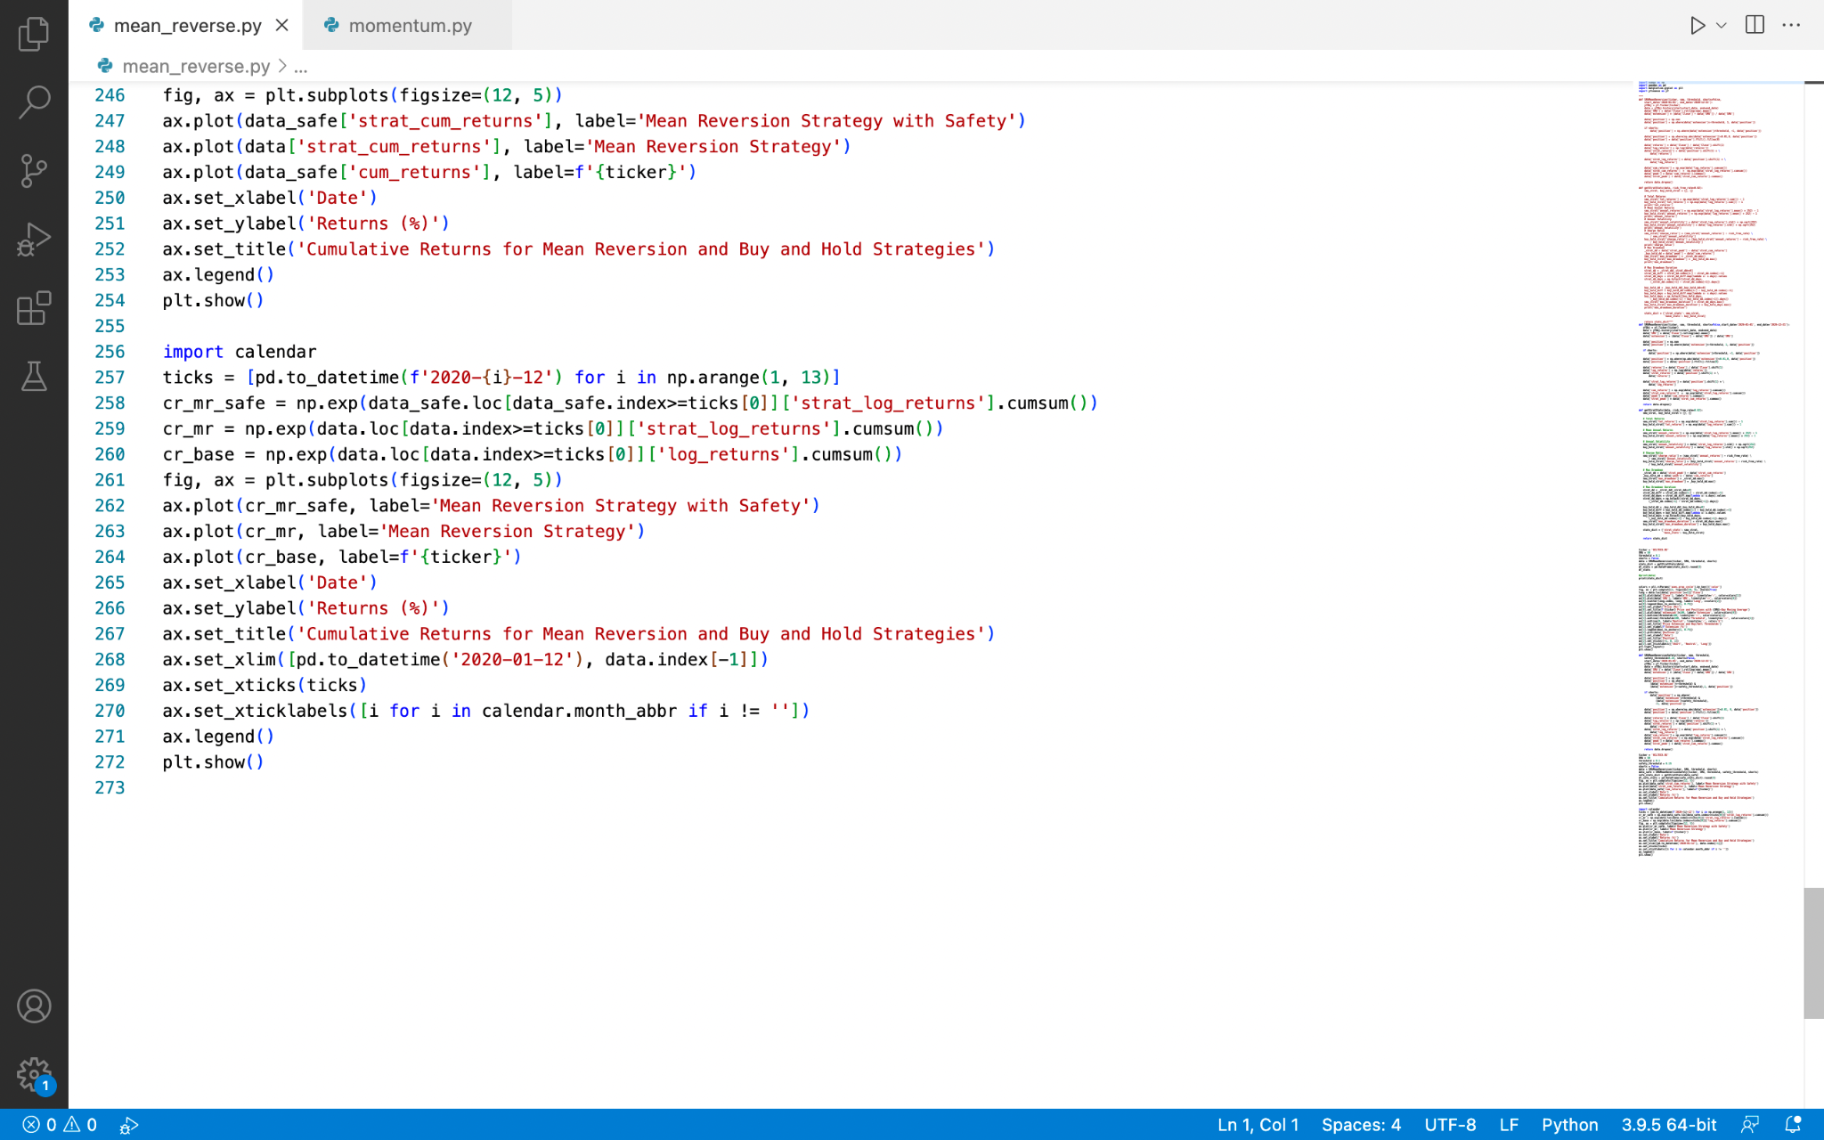

### Explanation

The brilliance of markets is that they are continually in motion. Even if they don't display high momentum or patterns at any particular time, you can still profit from a technique. You can profit and demonstrate strong returns by following the ups and downs of price action – even on top of a wider trend.

A mean reversion strategy purchases a security at an excessive low price and sells it at an elevated high price. When perfectly adjusted, this will allow us to profit from almost any stock market scenario, if it is perfectly adjusted, it will enable us to gain rewards from virtually most stock market scenarios (Raposa.trade).

The simple moving average (SMA) is a simple model that we use as a sign to purchase, vend, and short an asset. It is easily possible to code this in python. Firstly, I imported basic packages like pyplot to plot graphs, yfinance and numpy to gather historical data etc.

The code for this technique uses the SMA to detect if the cost of a stock is excessively high or low in comparison to the moving average . When the cost of a stock is comparatively lower, the code buys it in the hopes that it would rise, eventually reaching the moving average. If it's overbought to the upside, we sell or go short, with the anticipation that the price will fall in the near future(Raposa.trade).

After providing a ticker, our SMA period, the threshold, and whether or not we want to incorporate short positions, we call the code above. We utilise yfinance to acquire the data and apply our moving average with that information. The code calculates our extension as a percentage of our SMA indicator to determine if a movement is over or under extended.

Unfortunately, during strong, downward moves, this method is vulnerable to losses. This is seen in the graph above, where the model takes a significant blow during the current COVID meltdown in 2020. Due to its choice to hold the long position in the face of rising sales, the model ends up in the exact incorrect position in these situations.

To remedy this, a safety threshold, or a point at which the model has failed, can be included in this, being overly prolonged and momentum has surpassed mean reversion, signalling that the position should be exited.

Like portrayed in the results, almost every step of the way, the safety threshold model outperforms the mean reversion method without the safety parameter in this scenario. Finally, with a sideways moving stock, it is able to cut its losses amid large drawdowns like the COVID crash to maintain capital (Raposa.trade).

Adding this safety element raised overall returns while lowering annual volatility, increasing the Sharpe ratio, and reducing the severity of drawdowns.

Except for missing that significant drawdown, the mean reversion with safety model does not work . The other strategy allows it to work with greater capital and wait for the market to bottom out before entering a position. This, of course, compounds over the course of the year, transforming it into a far more profitable approach.

Therefore these techniques attempt to account for stocks' inherent inclination to return to their long-term average. This is an excellent technique to profit from bumpy and sideways markets.

### Results

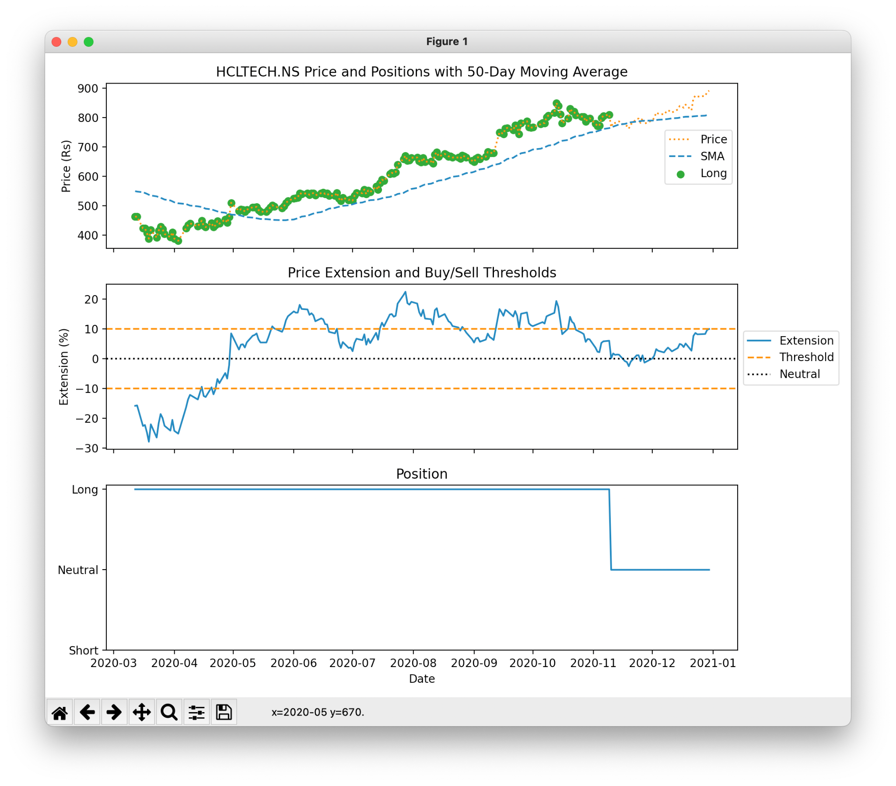

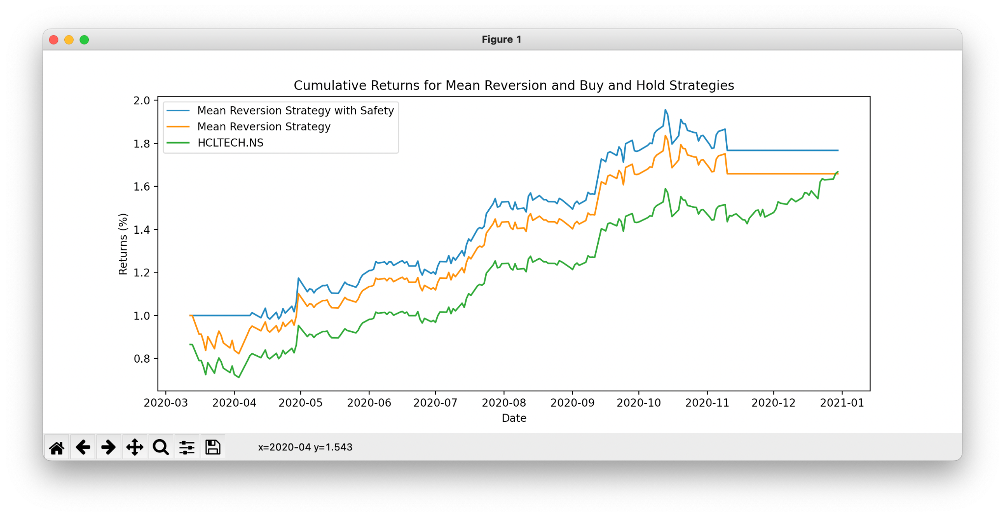

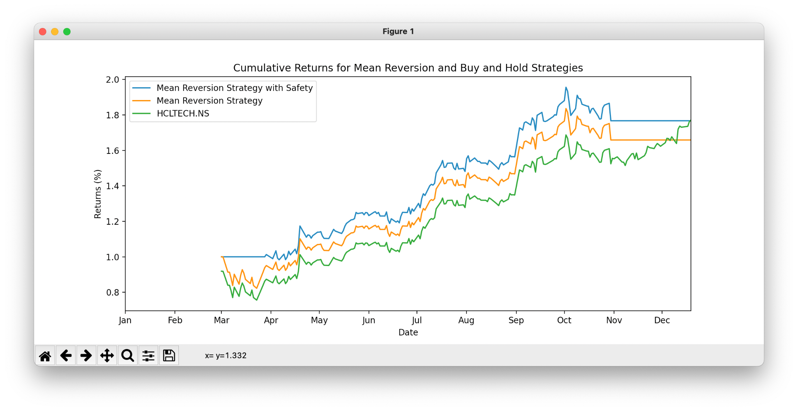



## Momentum Algorithm

### Code

According to Raposa.trade, the python code for momentum algorithm is as follows:

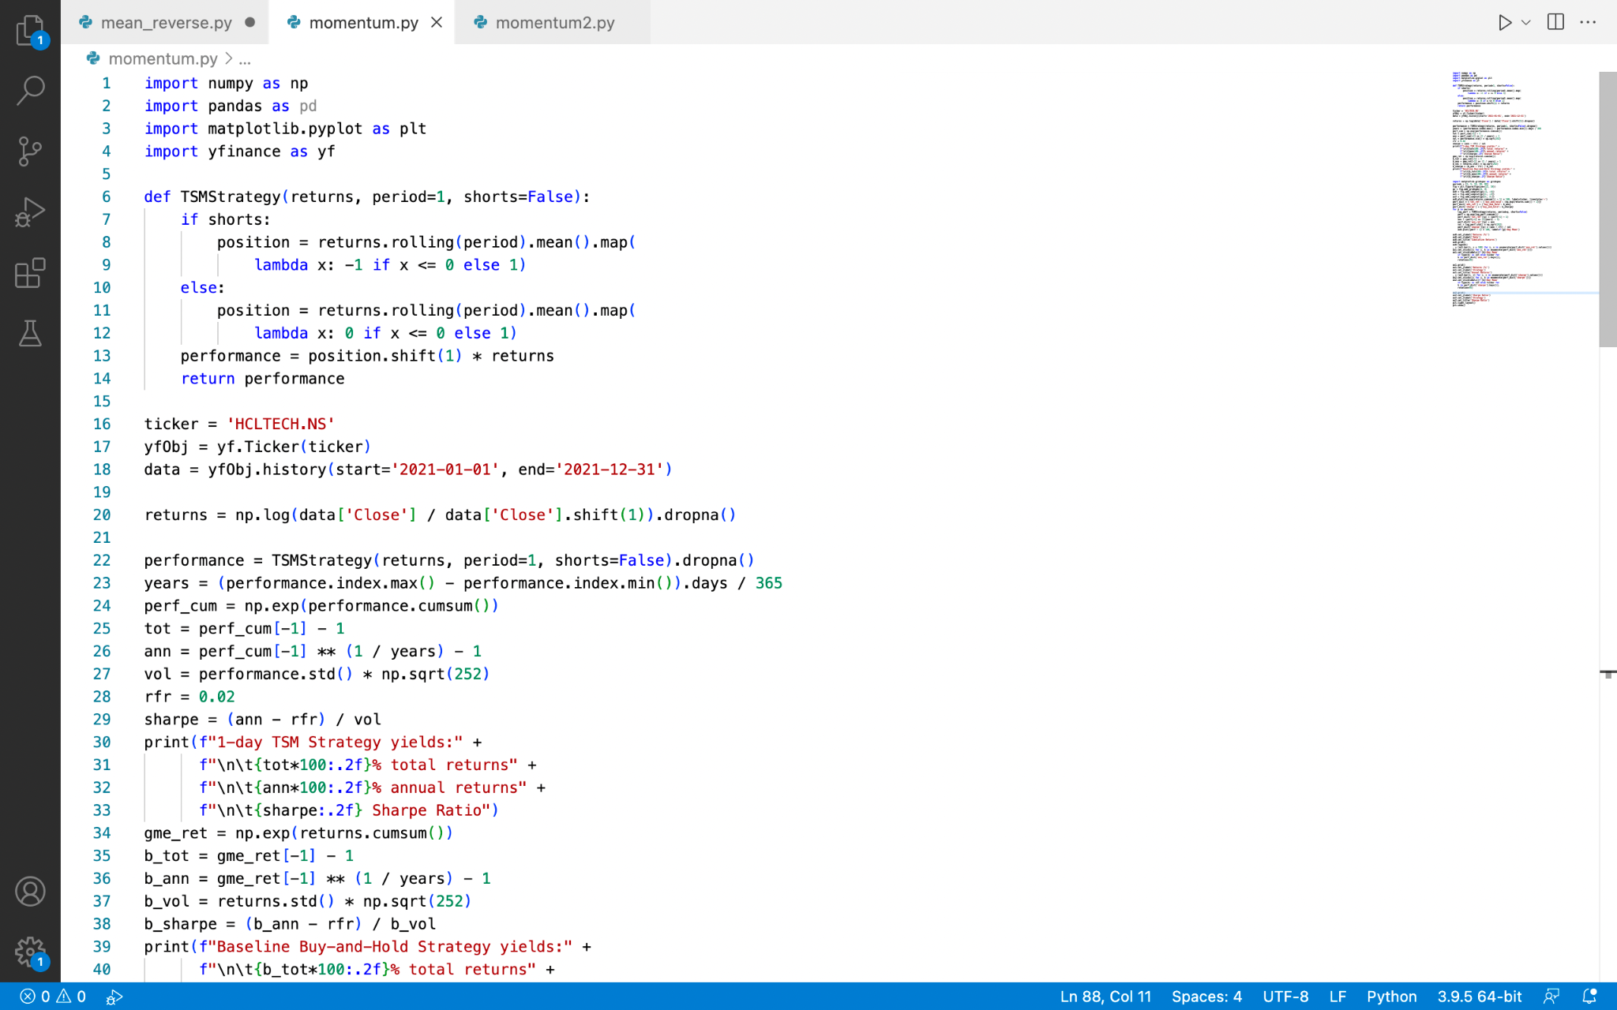

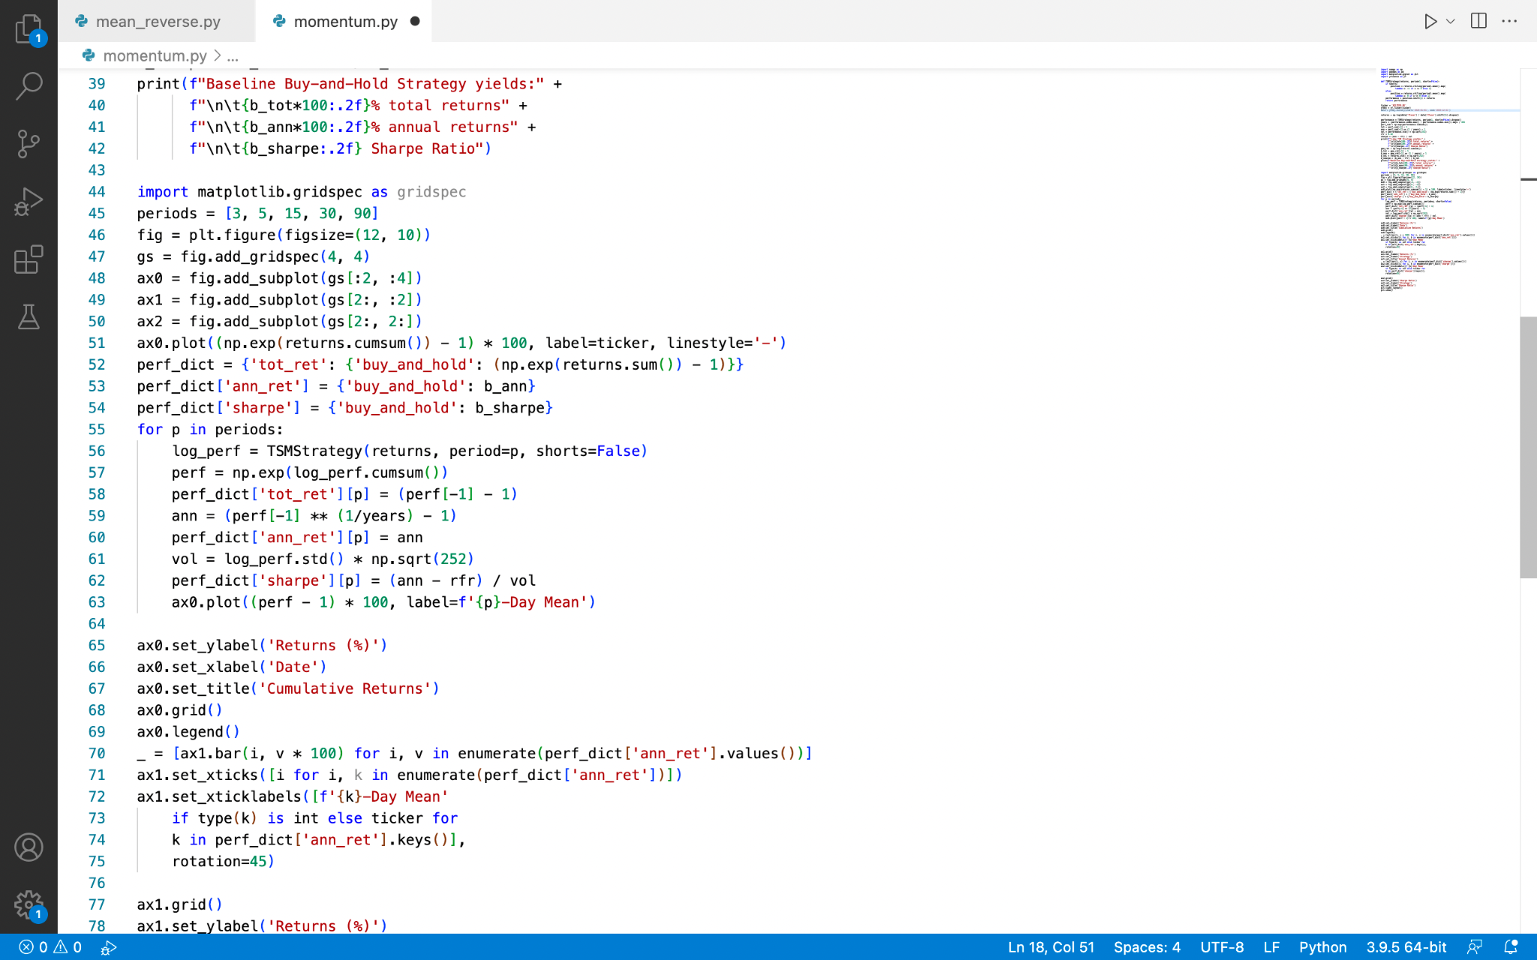

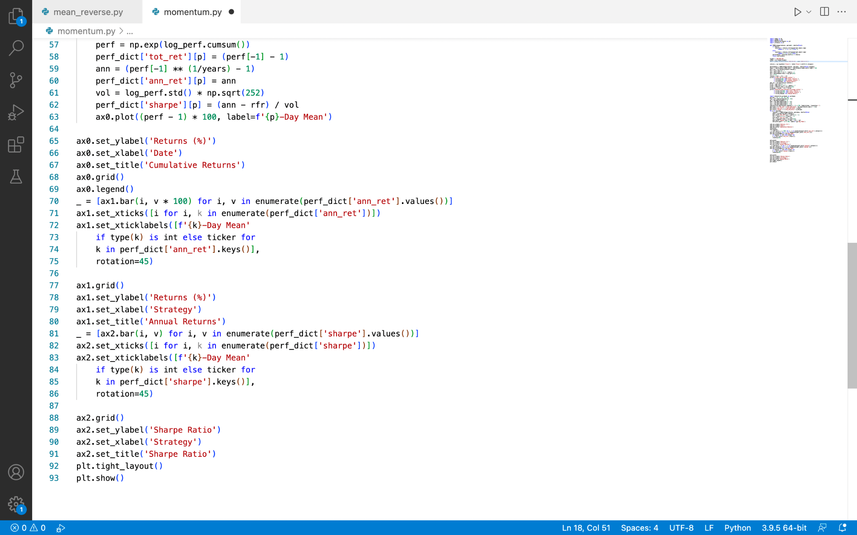

### 

### Explanation

Traders and investors have long been aware of the effects of momentum, which can be observed across a wide range of markets and time frames. Trend following or time series momentum are terms used to describe the execution of various tactics on a single instrument. We'll use the latter name and abbreviate it as TSM from now on.

While there are a variety of ways to implement this technique, including combining it with a variety of indicators, risk management overlays, and diversification, we'll start simple by demonstrating how it works on a single instrument.

Using python again, it is possible to create the algorithm. To begin with, we import the same standard libraries again.

This will accept our time series' log returns, the period we are interested in, and a boolean variable that indicates whether or not short positions are allowed. After that, the function will simulate the strategy for us and return the sum of the results for additional study.

It's a straightforward function for a basic but effective method. The next step is to feed it some information and observe how it responds. To observe how our model performs, I'm going to use the same stock, HCL Technologies.

We must calculate the log returns and submit them to our function in order to provide this to our approach.

The simplest TSM we can use is to buy the stock if it was up yesterday and sell it if it was down yesterday.

With a decent annual return, the 1-Day TSM approach outperforms the buy-and-hold strategy (ignoring transaction costs, which may be high given such a short term strategy). We can run a variety of various time periods to evaluate how they match up because the 1-day lookback is likely to be riddled with misleading trends. We'll just run our model in a loop for three, five, fifteen, thirty, and ninety days.

The 15-day momentum indicator, as seen above, provides the best absolute and risk-adjusted returns. These data, however, show a lot of variation. This suggests that our plan isn't very strong. Other indicators, such as moving averages or exponentially weighted moving averages, could be added to this basic method to indicate momentum. We might better control our risk by using stop losses or trailing stops to exit trades closer to the peak rather than when the 15-days are down or flat. We could also spread our money over several securities, allowing us to profit from diversification while also capitalising on emerging trends.

### Results

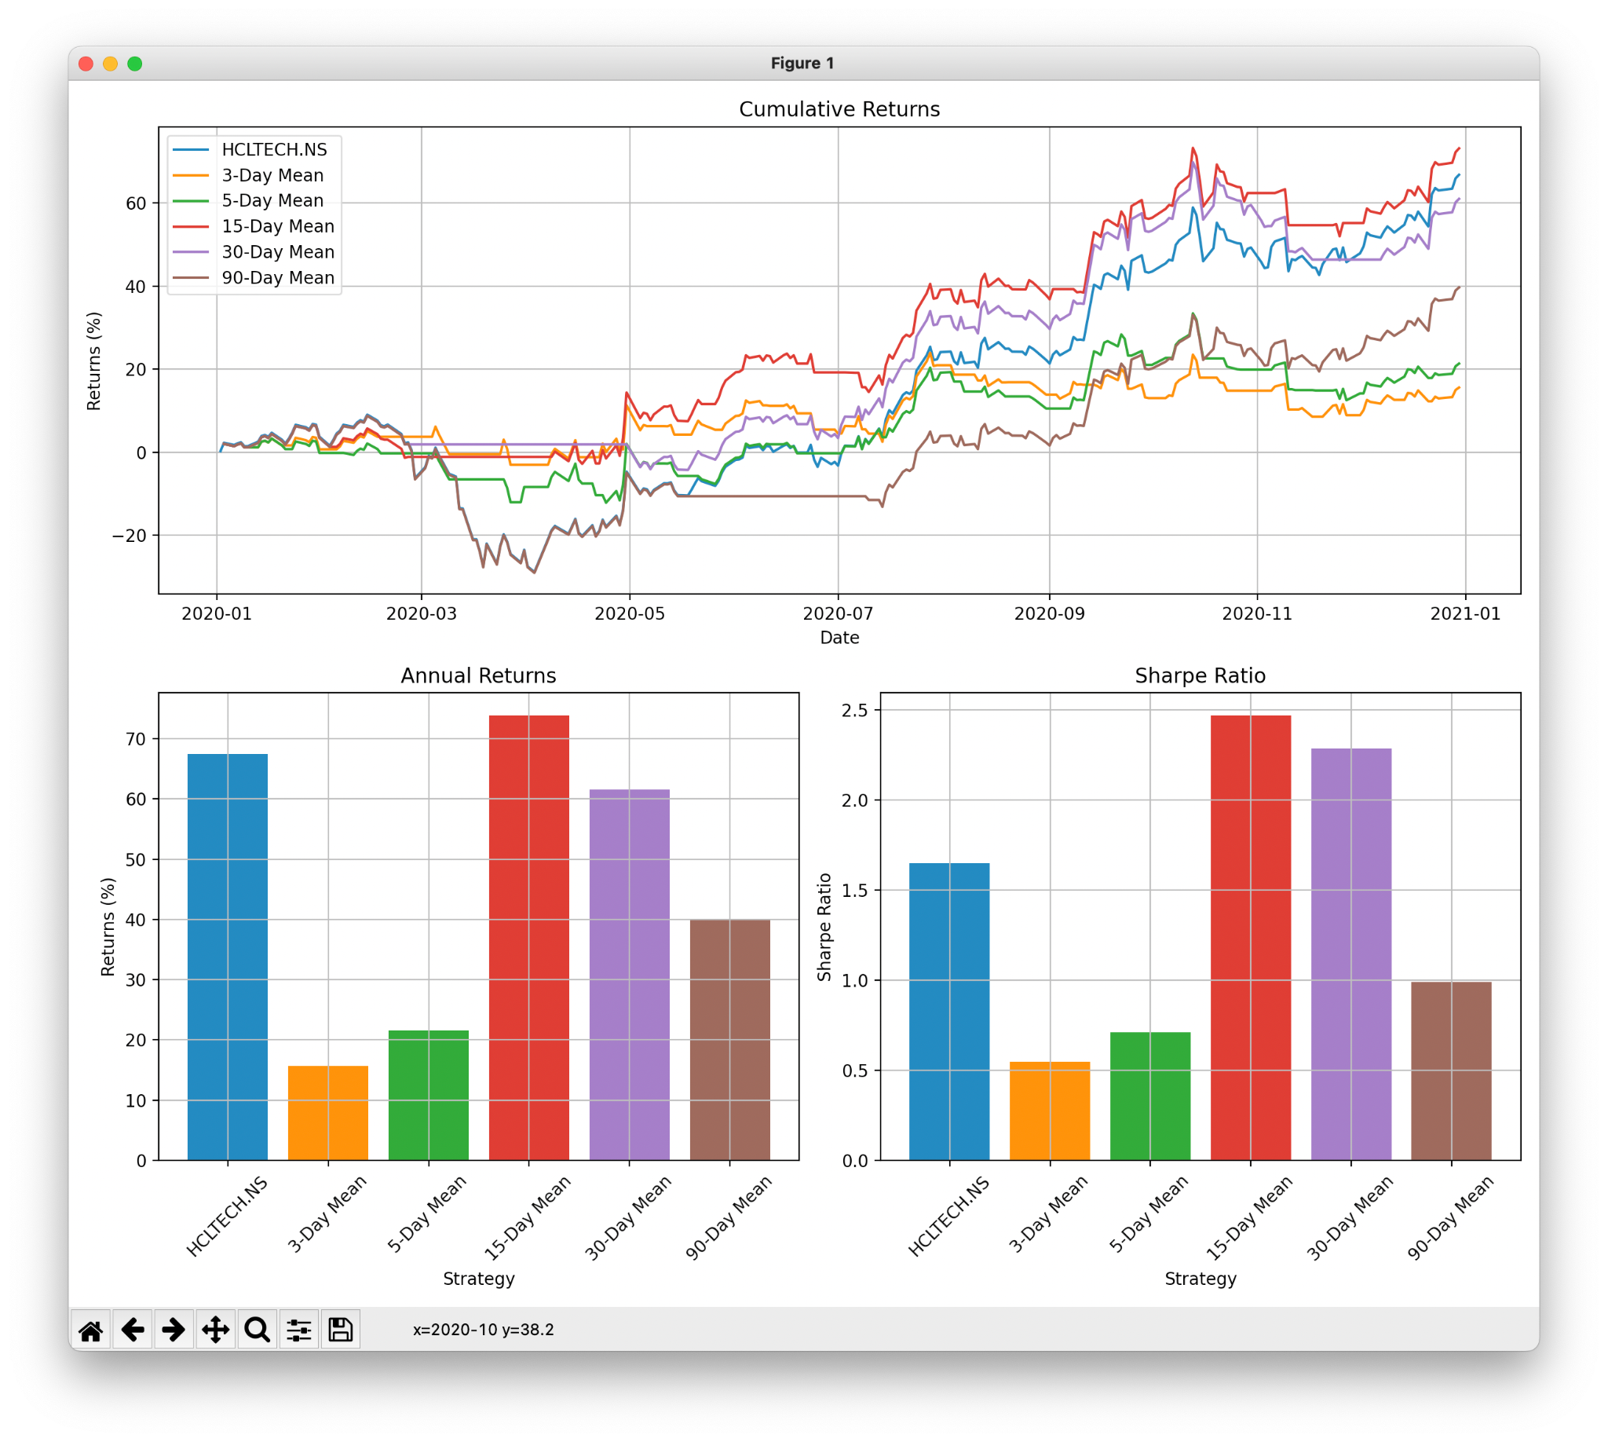

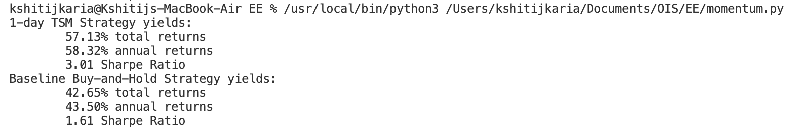



# Primary Research Analysis

The codes have been customised to match the secondary research. Now, for the primary data analysis we have the required results from the code. From the graph of the we notice that the rate of return is between 1.6% to 1.8%. While the rate of return is exponentially higher which is about 70% for the 15 day mean. From the terminal output we can see that the annual volatility is 0.294 for the momentum algorithm and 0.395 for the mean reversion algorithm. Annual Volatility is a measure of the variance of returns over a period of time. The sharpe ratio for the mean reversion algorithm is 2.45 whereas the sharpe ratio is 2.74, highlighting that the risk to return ratio is higher for the momentum algorithm than mean reversion. Everything indicated by the results of primary research is in sync with the expectations after the secondary research analysis.

# Conclusion

Through this essay, I have outlined the main elements like working, benefits and limitations of momentum algorithm and the mean reversion and momentum algorithm. The secondary research involves thorough analysis of both algorithms. The Primary Research shows the back end of the algorithms and expected results accordingly. However, I could have customised the program to match the secondary analysis even more for accurate results and optimised it further by optimising the parameters. To conclude, we can determine the difference in efficiency of these algorithms to evaluate maximum profits.

**Works Cited**

“Basics of Algorithmic Trading: Concepts and Examples.” *Investopedia*, May 11 ,2022, www.investopedia.com/articles/active-trading/101014/basics-algorithmic-trading-concepts-and-examples.asp.

Chen James “Backtesting Definition.” *Investopedia*,May 11 ,2022, www.investopedia.com/terms/b/backtesting.asp.

Chen, James “Oscillator Definition.” *Investopedia*,May 11 ,2022, www.investopedia.com/terms/o/oscillator.asp.

Chen, James.“Mean Reversion.” *Investopedia*, May 11 ,2022, www.investopedia.com/terms/m/meanreversion.asp.

“How to Build Your First Momentum Trading Strategy in Python — Raposa.” *Raposa*, May 11 ,2022, raposa.trade/blog/how-to-build-your-first-momentum-trading-strategy-in-python/.

“How to Build Your First Mean Reversion Trading Strategy in Python.” *Raposa*, May 11 ,2022, raposa.trade/blog/how-to-build-your-first-mean-reversion-trading-strategy-in-python/.

Barone, Adam “Introduction to Momentum Trading?” Investopedia, May 11 ,2022, www.investopedia.com/trading/introduction-to-momentum-trading/.

“Mean Reversion vs. Momentum Strategies: Which Is Better? - Phemex Academy.” *Phemex*, May 11 ,2022, phemex.com/academy/mean-reversion-vs-momentum-trading-strategy#:~:text=While%20mean%20reversion%20strategy%20allows,understood%20by%20any%20serious%20trader..

Marwood, Joe. “How to Build a Mean Reversion Trading Strategy.” *Decoding Markets*, May 11 ,2022, decodingmarkets.com/mean-reversion-trading-strategy/

“Streak | Create, Backtest and Deploy Trading Strategies.” Streak.tech, 2022, www.streak.tech/backtests?publishing_uuid=Njg3ZWU2ZTYtZmQ4OS00Yjk5LWI1MDctYmY3MmMxNTljYTRi.‌

“Streak | Create, Backtest and Deploy Trading Strategies.” Streak.tech,May 11 ,2022, www.streak.tech/backtests?algo_uuid=OTdmYTNmMTAtMzFkMi00NDI2LTkxNDAtYjI2NjVhYjA5OTQw.

‌“Types of Trading Strategies | Pros & Cons | Algo Trading Strategy Types.” *Trading Tuitions*, May 11 ,2022, tradingtuitions.com/types-of-trading-strategies-detailed-comparison/.

Singh, Gaurav “Momentum Trading: Types, Benefits, Strategies, and More.” *Quantitative Finance & Algo Trading Blog by QuantInsti*, Quantitative Finance & Algo Trading Blog by QuantInsti,May 11 ,2022, blog.quantinsti.com/momentum-trading-strategies/.

‌